**BANK LOAN REPORT QUERY DOCUMENT**

1. **BANK LOAN REPORT | SUMMARY**

**KPI’S:**

**Total Loan Applications**





**MTD Loan Applications**





**PMTD Loan Applications**





**Total Funded Amount**





**MTD Funded Amount**





**PMTD Funded Amount**





**Total Amount Received**





**MTD Amount Received**





**PMTD Amount Received**





**Average Interest Rate**





**MTD Average Interest Rate**





**PMTD Average Interest Rate**





**Average DTI**

 

**MTD Average DTI**





**PMTD Average DTI**





**Good Loan Applications Percentage**





**Good Loan Applications**





**Good Loan Funded Amount**





**Good Loan Total Received Amount**





**Bad Loan Applications Percentage**





**Bad Loan Applications**





**Bad Loan Funded Amount**





**Bad Loan Total Received Amount**





**Loan status**

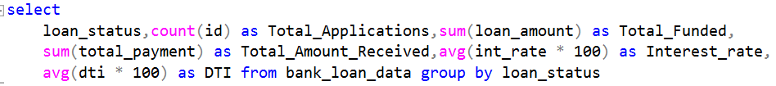

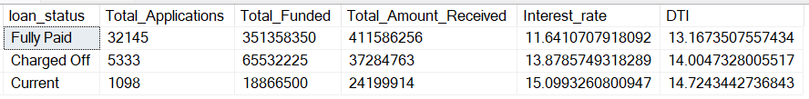

**MTD loan status**

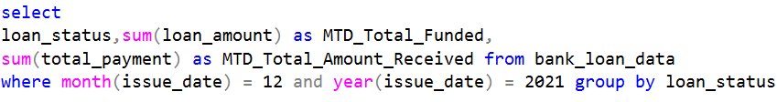

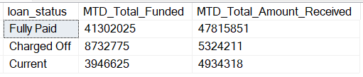

1. **BANK LOAN REPORT | OVERVIEW**

**Monthly Trends**



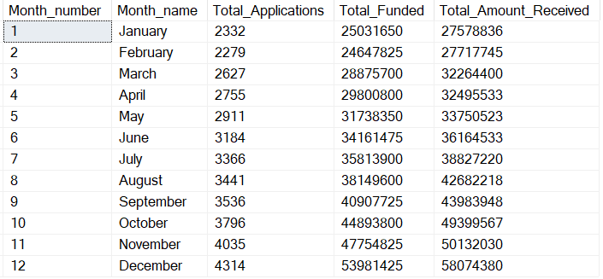

**State wise Trends**



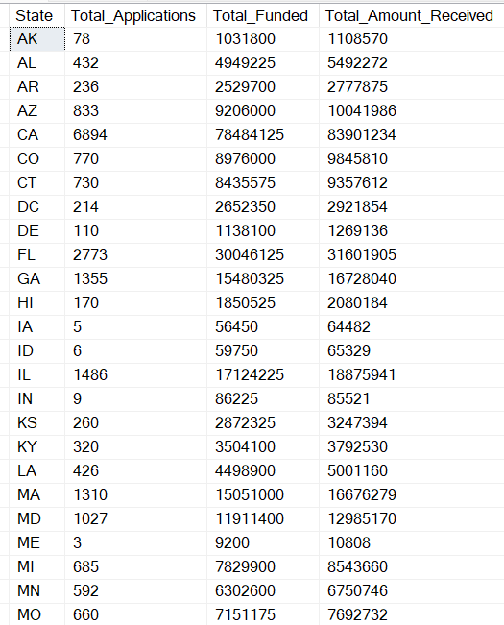

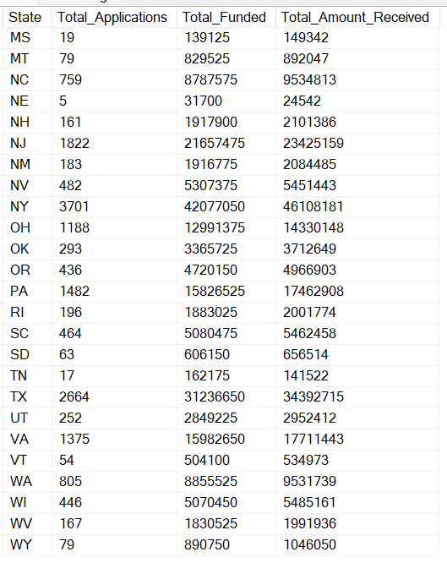

**Loan Term analysis**



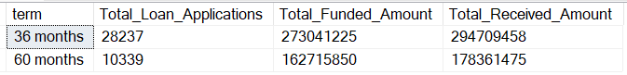

**Employee Length Analysis**



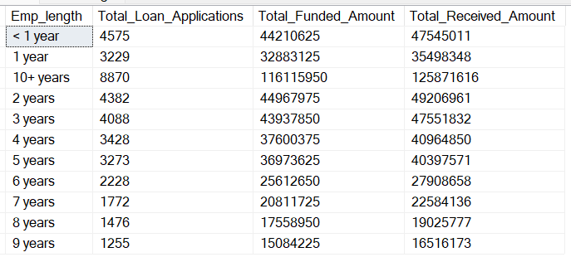

**Loan Purpose Breakdown**



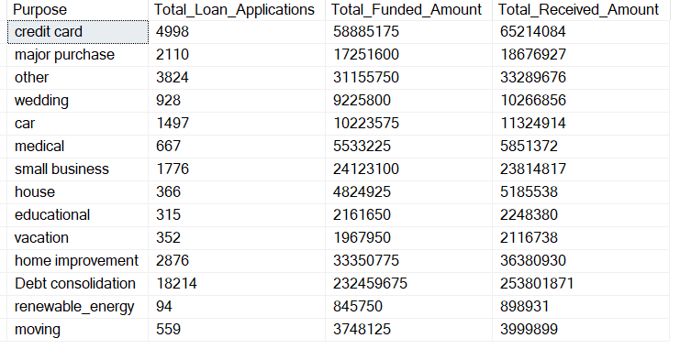

**Home ownership Analysis**



